In this Lab, you will:

1. Create a branch
2. Commit a file
3. Open a pull request
4. Merge your pull request

Please sign in to GitHub and create a repository from the link below and follow the steps:

https://github.com/new

**Step 1: Create a branch**

*Welcome to "Introduction to GitHub"! 👋*

**What is GitHub?**: GitHub is a collaboration platform that uses [*Git*](https://docs.github.com/get-started/quickstart/github-glossary#git) for versioning. GitHub is a popular place to share and contribute to [open-source](https://docs.github.com/get-started/quickstart/github-glossary#open-source) software.   
📺 [Video: What is GitHub?](https://www.youtube.com/watch?v=pBy1zgt0XPc)

**What is a repository?**: A [*repository*](https://docs.github.com/get-started/quickstart/github-glossary#repository) is a project containing files and folders. A repository tracks versions of files and folders. For more information, see "[About repositories](https://docs.github.com/en/repositories/creating-and-managing-repositories/about-repositories)" from GitHub Docs.

**What is a branch?**: A [*branch*](https://docs.github.com/en/get-started/quickstart/github-glossary#branch) is a parallel version of your repository. By default, your repository has one branch named main and it is considered to be the definitive branch. Creating additional branches allows you to copy the main branch of your repository and safely make any changes without disrupting the main project. Many people use branches to work on specific features without affecting any other parts of the project.

Branches allow you to separate your work from the main branch. In other words, everyone's work is safe while you contribute. For more information, see "[About branches](https://docs.github.com/en/pull-requests/collaborating-with-pull-requests/proposing-changes-to-your-work-with-pull-requests/about-branches)".

**What is a profile README?**: A [*profile README*](https://docs.github.com/account-and-profile/setting-up-and-managing-your-github-profile/customizing-your-profile/managing-your-profile-readme) is essentially an "About me" section on your GitHub profile where you can share information about yourself with the community on GitHub.com. GitHub shows your profile README at the top of your profile page. For more information, see "[Managing your profile README](https://docs.github.com/en/account-and-profile/setting-up-and-managing-your-github-profile/customizing-your-profile/managing-your-profile-readme)".

[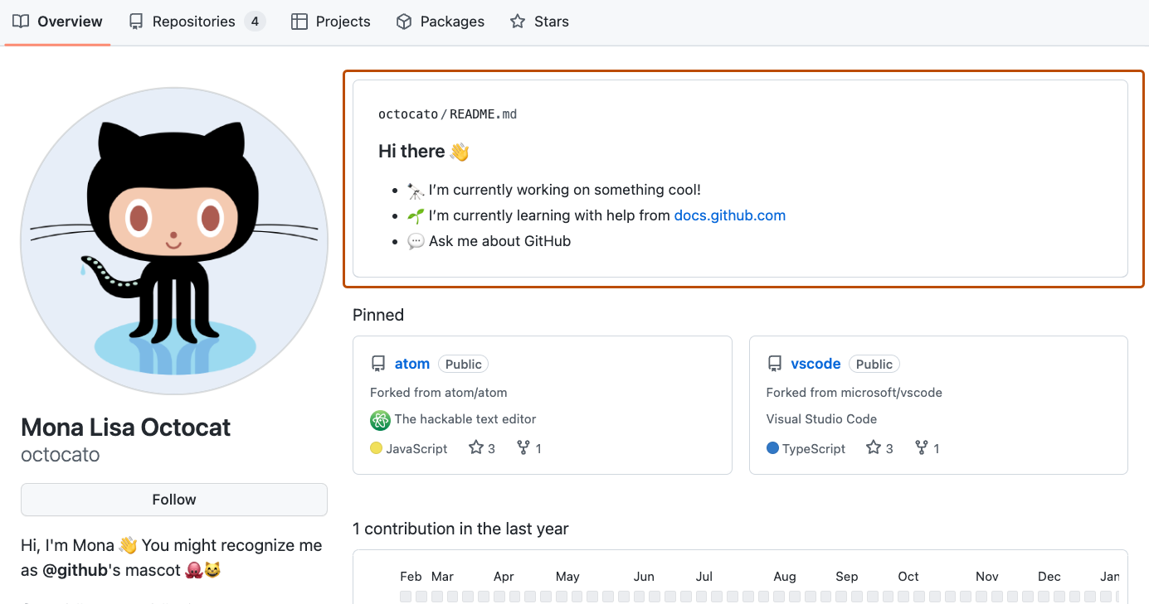](https://github.com/deepanshuMeteor/skills-introduction-to-github/blob/main/images/profile-readme-example.png)

**⌨️ Activity: Your first branch**

1. Open a new browser tab and navigate to your newly made repository. Then, work on the steps in your second tab while you read the instructions in this tab.
2. Navigate to the **< > Code** tab in the header menu of your repository.

[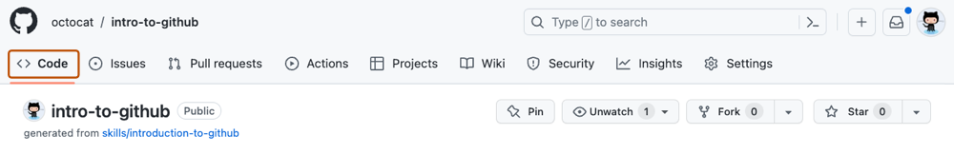](https://github.com/deepanshuMeteor/skills-introduction-to-github/blob/main/images/code-tab.png)

1. Click on the **main** branch drop-down.

[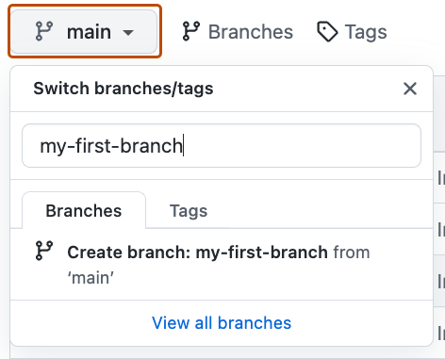](https://github.com/deepanshuMeteor/skills-introduction-to-github/blob/main/images/main-branch-dropdown.png)

1. In the field, name your branch my-first-branch. In this case, the name must be my-first-branch to trigger the course workflow.
2. Click **Create branch: my-first-branch** to create your branch.

[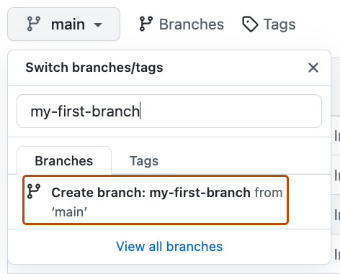](https://github.com/deepanshuMeteor/skills-introduction-to-github/blob/main/images/create-branch-button.png)

The branch will automatically switch to the one you have just created. The **main** branch drop-down bar will reflect your new branch and display the new branch name.

**Step 2: Commit a file**

*You created a branch! 🎉*

Creating a branch allows you to edit your project without changing the main branch. Now that you have a branch, it’s time to create a file and make your first commit!

**What is a commit?**: A [*commit*](https://docs.github.com/pull-requests/committing-changes-to-your-project/creating-and-editing-commits/about-commits) is a set of changes to the files and folders in your project. A commit exists in a branch. For more information, see "[About commits](https://docs.github.com/en/pull-requests/committing-changes-to-your-project/creating-and-editing-commits/about-commits)".

**⌨️ Activity: Your first commit**

The following steps will guide you through the process of committing a change on GitHub. A commit records changes in renaming, changing content within, creating a new file, and any other changes made to your project. For this exercise, committing a change requires first adding a new file to your new branch.

Note

.md is a file extension that creates a Markdown file. You can learn more about Markdown by visiting "[Basic writing and formatting syntax](https://docs.github.com/en/get-started/writing-on-github/getting-started-with-writing-and-formatting-on-github/basic-writing-and-formatting-syntax)" in our docs or by taking the "[Communicating using Markdown](https://github.com/skills/communicate-using-markdown)" Skills course.

1. On the **< > Code** tab in the header menu of your repository, make sure you're on your new branch my-first-branch.
2. Select the **Add file** drop-down and click **Create new file**.

[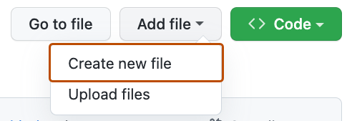](https://github.com/deepanshuMeteor/skills-introduction-to-github/blob/my-first-branch/images/create-new-file.png)

1. In the **Name your file...** field, enter PROFILE.md.
2. In the **Enter file contents here** area, copy the following content to your file:
3. Welcome to my GitHub profile!

• [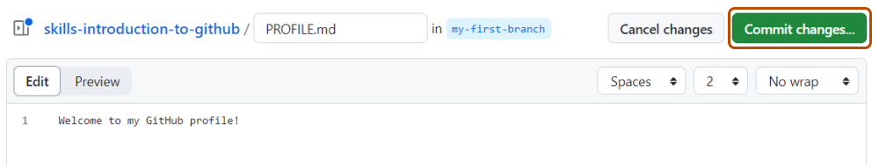](https://github.com/deepanshuMeteor/skills-introduction-to-github/blob/my-first-branch/images/my-profile-file.png)

• Click **Commit changes...** in the upper right corner above the contents box. For commits, you can enter a short commit message that describes what changes you made. This message helps others know what's included in your commit. GitHub offers a simple default message, but let's change it slightly for practice. First, enter Add PROFILE.md in the first text-entry field titled "Commit message".

[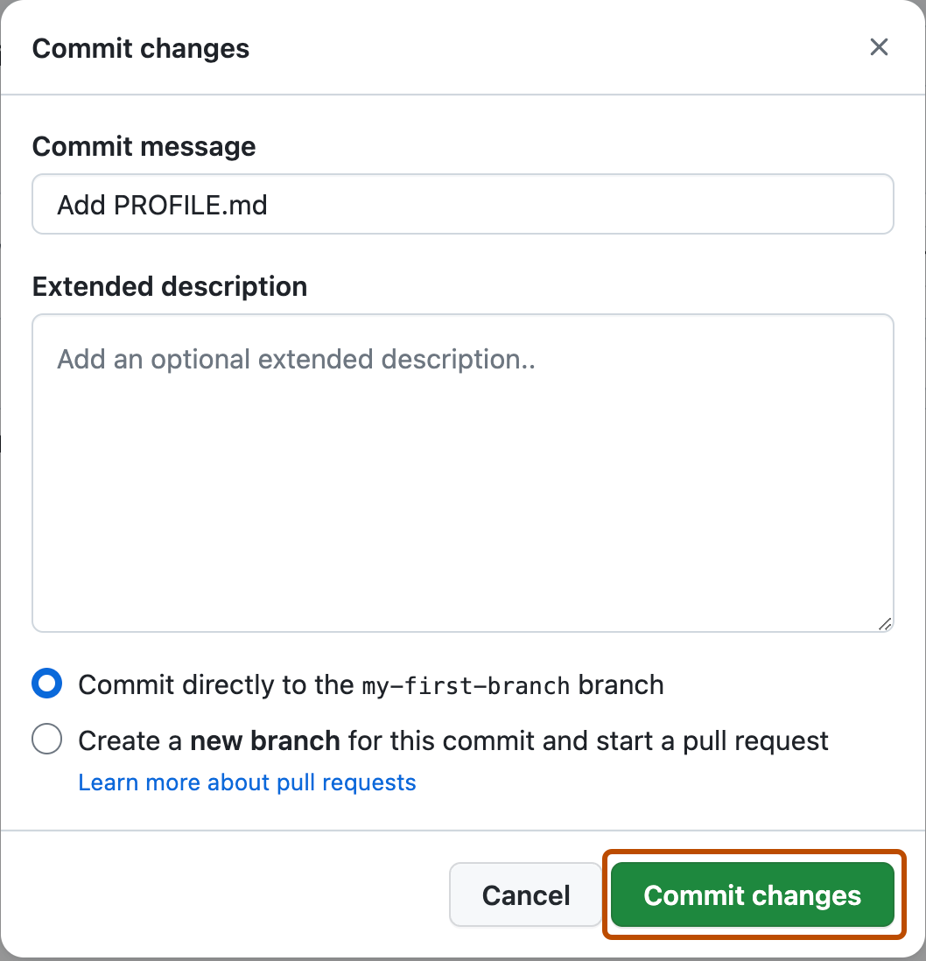](https://github.com/deepanshuMeteor/skills-introduction-to-github/blob/my-first-branch/images/commit-full-screen.png)

• In this lesson, we'll ignore the other fields and click **Commit changes**.

**Step 3: Open a pull request**

*Nice work making that commit! ✨*

Now that you have made a change to the project and created a commit, it’s time to share your proposed change through a pull request!

**What is a pull request?**: Collaboration happens on a [*pull request*](https://docs.github.com/en/get-started/quickstart/github-glossary#pull-request). The pull request shows the changes in your branch to other people and allows people to accept, reject, or suggest additional changes to your branch. In a side by side comparison, this pull request is going to keep the changes you just made on your branch and propose applying them to the main project branch. For more information about pull requests, see "[About pull requests](https://docs.github.com/en/pull-requests/collaborating-with-pull-requests/proposing-changes-to-your-work-with-pull-requests/about-pull-requests)".

**⌨️ Activity: Create a pull request**

You may have noticed after your commit that a message displayed indicating your recent push to your branch and providing a button that says **Compare & pull request**.

[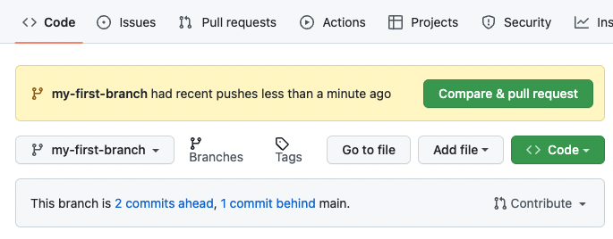](https://github.com/deepanshuMeteor/skills-introduction-to-github/blob/my-first-branch/images/compare-and-pull-request.png)

To create a pull request automatically, click **Compare & pull request**, and then skip to step 6 below. If you don't click the button, the instructions below walk you through manually setting up the pull request.

1. Click on the **Pull requests** tab in the header menu of your repository.
2. Click **New pull request**.
3. In the **base:** dropdown, make sure **main** is selected.
4. Select the **compare:** dropdown, and click my-first-branch.

[](https://github.com/deepanshuMeteor/skills-introduction-to-github/blob/my-first-branch/images/pull-request-branches.png)

1. Click **Create pull request**.
2. Enter a title for your pull request. By default, the title will automatically be the name of your branch. For this exercise, let's edit the field to say Add my first file.
3. The next field helps you provide a description of the changes you made. Here, you can add a description of what you’ve accomplished so far. As a reminder, you have: created a new branch, created a file, and made a commit.

[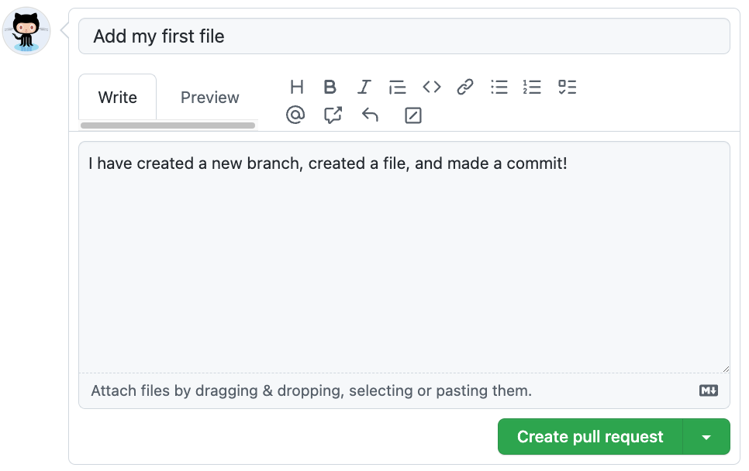](https://github.com/deepanshuMeteor/skills-introduction-to-github/blob/my-first-branch/images/Pull-request-description.png)

1. Click **Create pull request**. You will automatically be navigated to your new pull request.

Note

You may see evidence of GitHub Actions running on the tab with the pull request opened! The image below shows a line you might see on your pull request after the Action finishes running.

[screenshot of an example of an actions line](https://github.com/deepanshuMeteor/skills-introduction-to-github/blob/my-first-branch/images/Actions-to-step-4.png)

**Step 4: Merge your pull request**

*Nicely done! 😎*

You successfully created a pull request. You can now merge your pull request.

**What is a merge?**: A [*merge*](https://docs.github.com/en/get-started/quickstart/github-glossary#merge) adds the changes in your pull request and branch into the main branch. For more information about merges, see "[Merging a pull request](https://docs.github.com/en/pull-requests/collaborating-with-pull-requests/incorporating-changes-from-a-pull-request/merging-a-pull-request)."

As noted in the previous step, you may have seen evidence of GitHub Actions running which automatically progresses your instructions to the next step. You'll have to wait for it to finish before you can merge your pull request. It will be ready when the merge pull request button is green.

[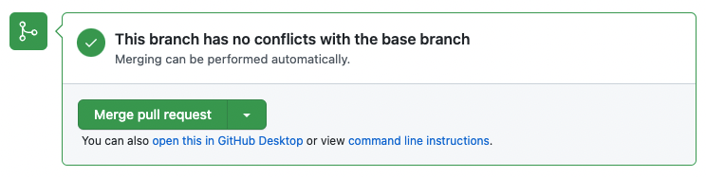](https://github.com/deepanshuMeteor/skills-introduction-to-github/blob/main/images/Green-merge-pull-request.png)

**⌨️ Activity: Merge the pull request**

1. Click **Merge pull request**.
2. Click **Confirm merge**.
3. Once your branch has been merged, you don't need it anymore. To delete this branch, click **Delete branch**.

[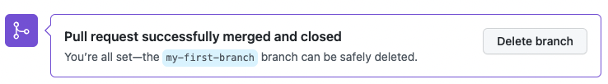](https://github.com/deepanshuMeteor/skills-introduction-to-github/blob/main/images/delete-branch.png)